Yarn Architecture

1. <https://www.youtube.com/watch?v=oz8TwPgDhc4>
2. <https://www.youtube.com/watch?v=ZFbkNY6Xn94>

read from the sheet notes

<https://www.youtube.com/watch?v=O-yLgxaCAGc>

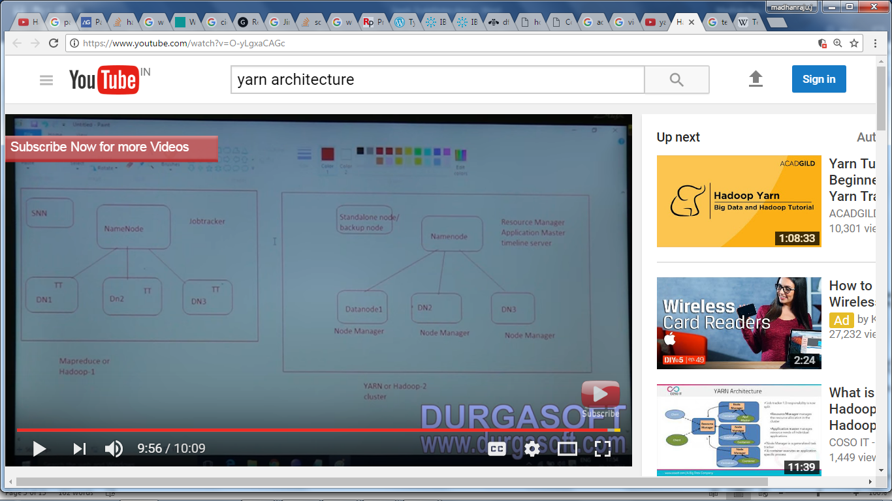

Differences: MR1 and MR2(Yarn)

1. Single point of failure – in MR1 we had only Jobtracker – which was responsible of resource allocation, job scheduling, and maintaining the history of the job (so the cluster had over burden)
2. In MR2 - job handled by JobTracker is split across - Resource Manger, Application master, and timeline server which keeps job history ; we also had standalone serve/backup server, in place of SNN(Secondary Name Node )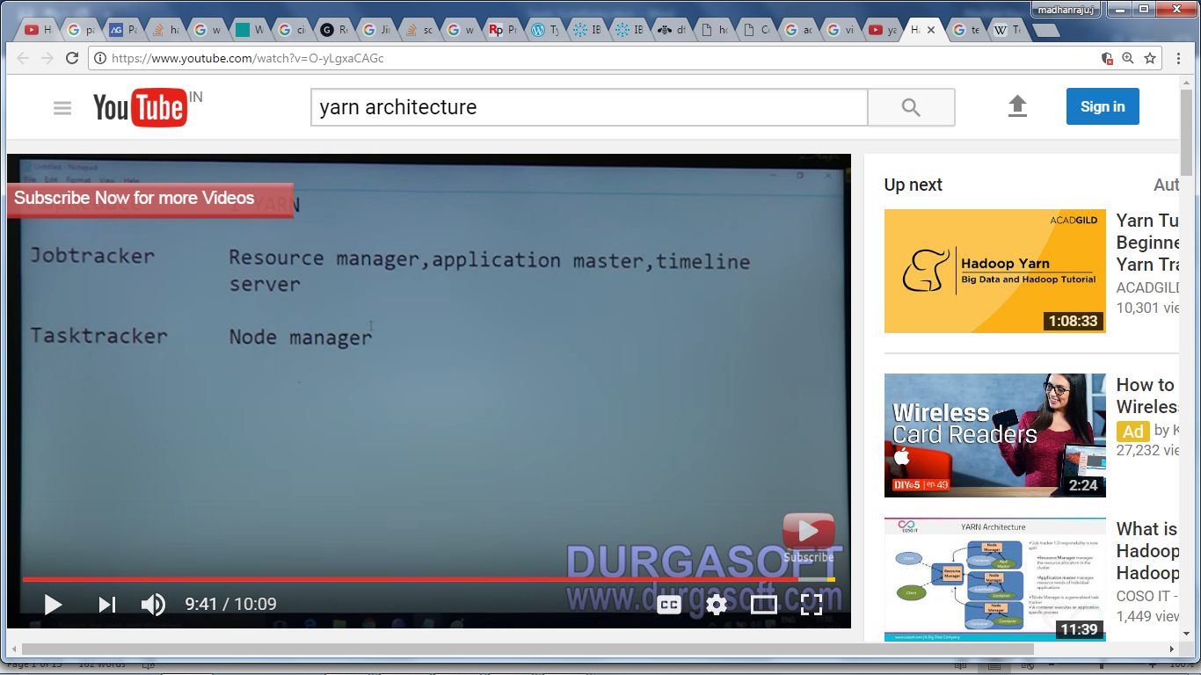
3. <https://www.youtube.com/watch?v=oz8TwPgDhc4>
4. <https://www.youtube.com/watch?v=ZFbkNY6Xn94>

https://www.youtube.com/watch?v=oz8TwPgDhc4

